**Constructed Packet at Server:**

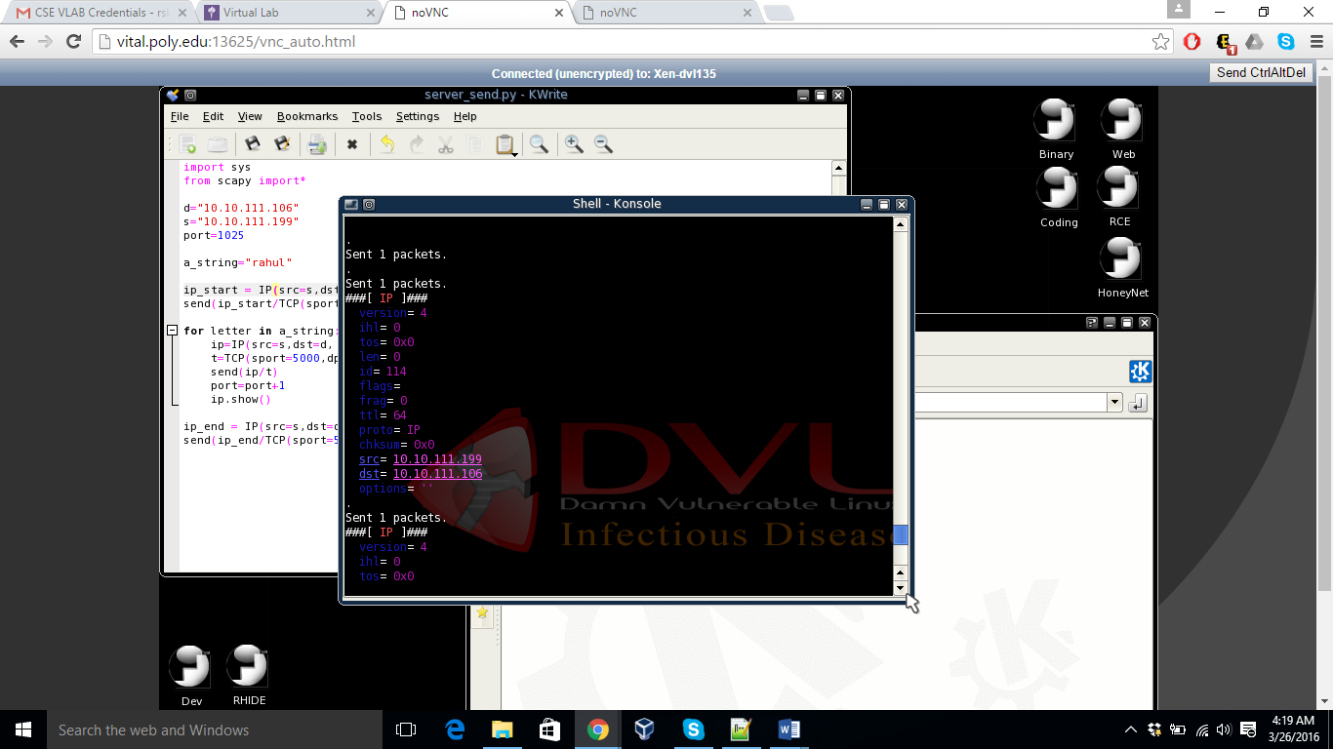

**Message to indicate beginning of covert communication**

Identification field as 0000

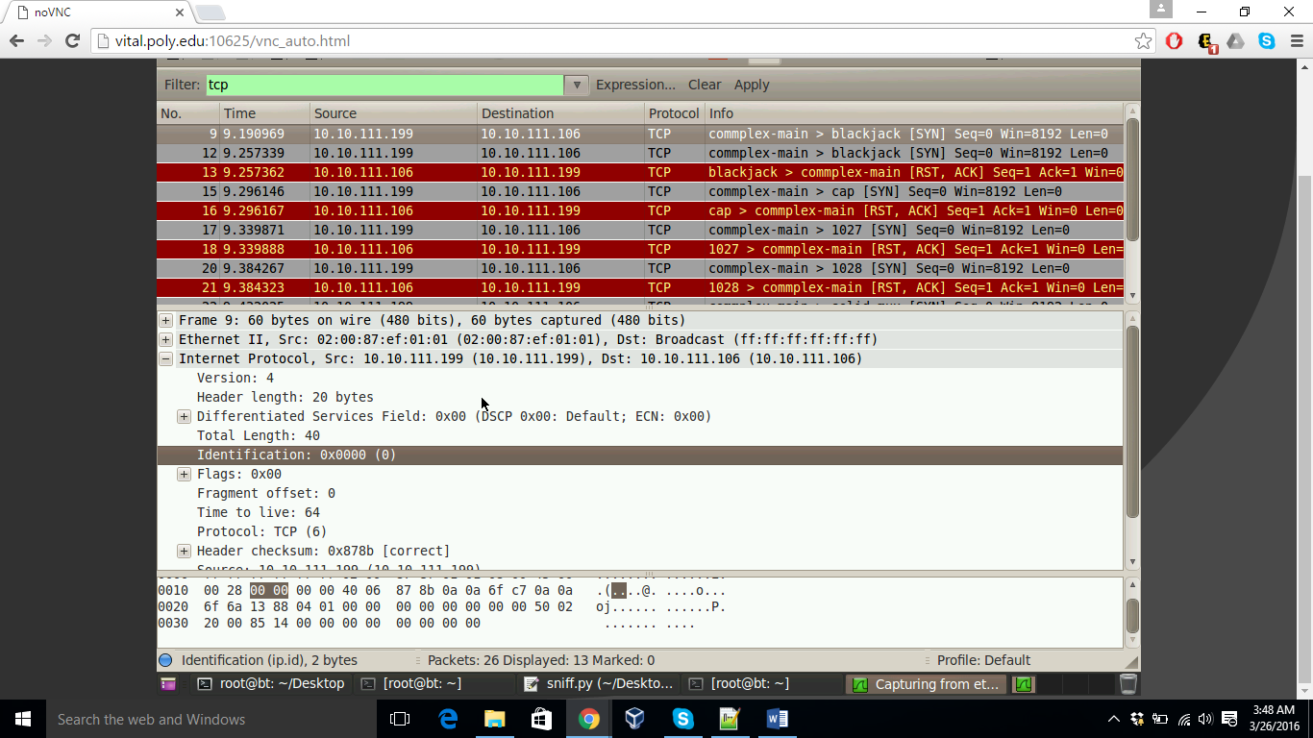

ASCII value for ‘r’ is 114

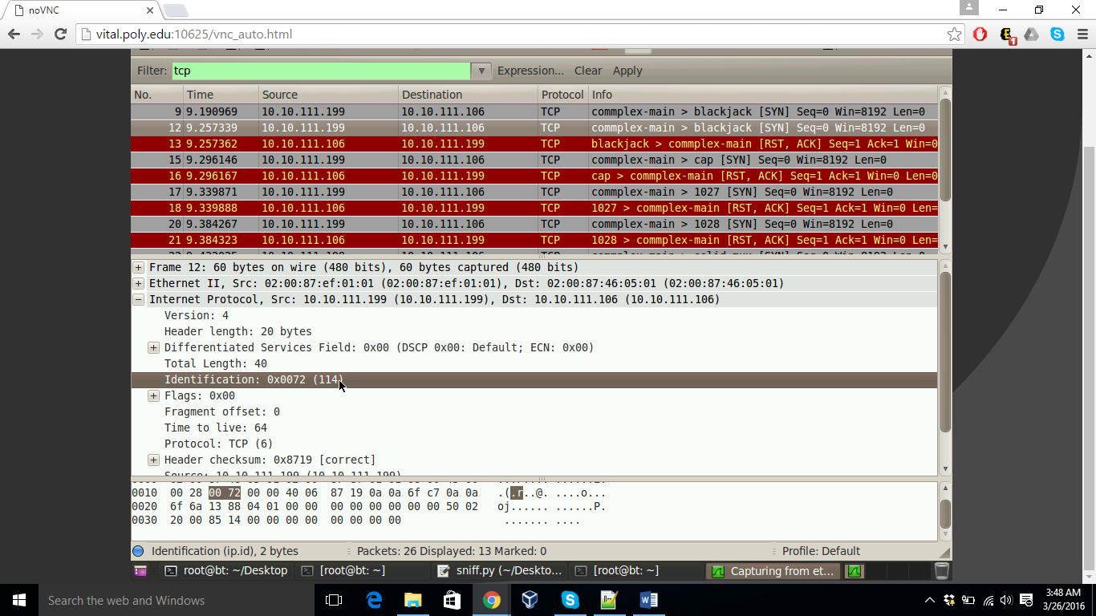

ASCII value for ‘a’ is 97

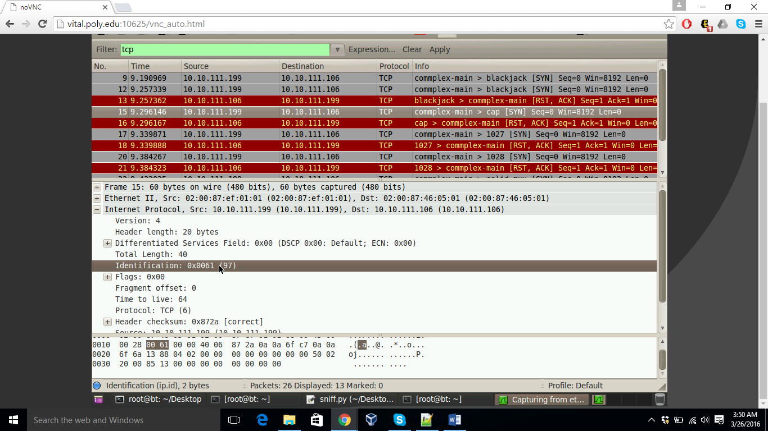

ASCII value for ‘h’ is 104

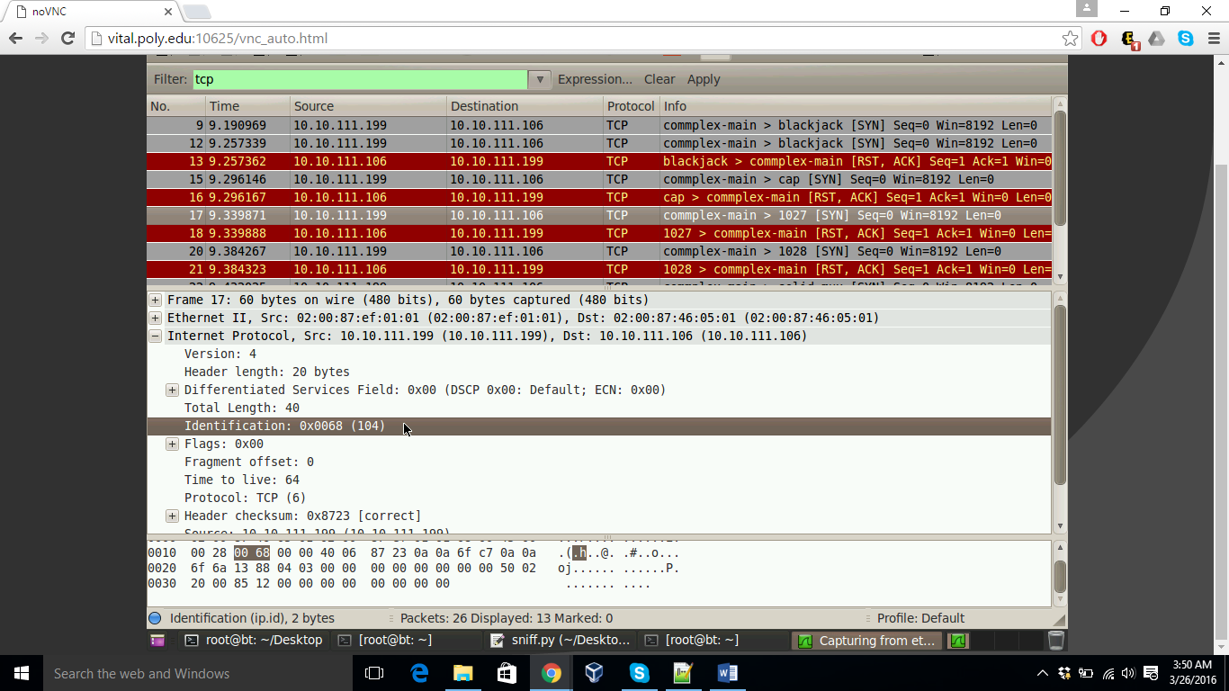

ASCII value for ‘u’ is 117

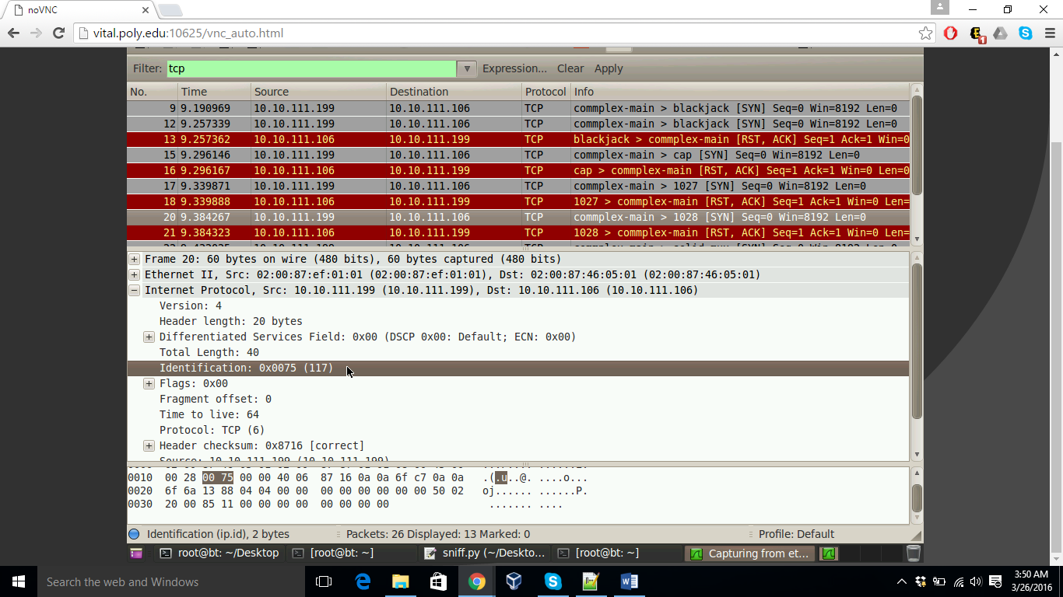

ASCII value for ‘l’ is 108

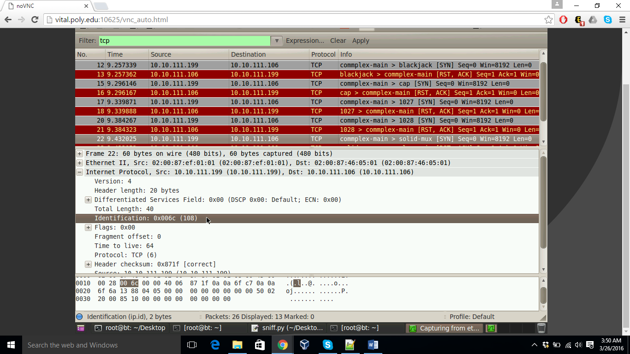

Identification value as 1111 to indicate end of covert communication

